Assignment Day 6 | 7th December 2020

# For any doubts regarding the assignment, ask questions in the L

[**Administration 101 B1**](https://community.letsupgrade.in/group/linux-administration-101-b1) **Group in the Community. Submit Assignments by 12th December 2020 11:59 PM.**

[**inux**](https://community.letsupgrade.in/group/linux-administration-101-b1)



**Assignment Submit Form :**[**https://forms.gle/9MNzWbdDXhhdstWEA**](https://forms.gle/9MNzWbdDXhhdstWEA)

**Submit assignments in Appropriate Dropdowns.**

**Question 1**

1. Use ps to search for the “systemd” process by name.
2. Find out your terminal name.Using your terminal name, use ps to find all processes associated With your terminal.
3. Check and note the process id of your shell(from the output of the above command). Also, note the parent process id of your shell.

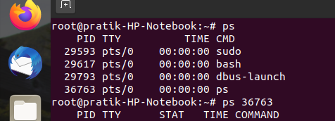

1. Start 3 instances of “sleep 123” as background processes.

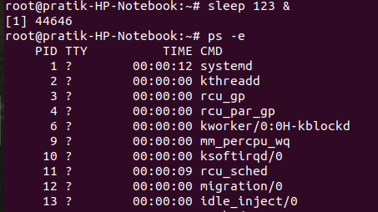

1. Check and note the process id’s of all sleep processes.

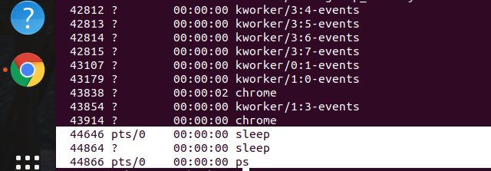

1. Display only those three sleep processes in top. Then quit top.

